A Study of Genesis 12-25
创12-25研经

LESSON 12
第十二课
THE DEATH AND BURIAL OF SARAH – GENESIS 23
撒拉死亡埋葬-创23

INTRODUCTION
简介
We might wonder what Sarah thought as her husband and long-awaited son left for Moriah without a sacrificial lamb (chapter 22). Did Abraham tell her what God had instructed him to do? We do not know, but this next chapter begins with the account of the death and burial of Sarah some years later.
我们可能会说，丈夫和好不容易盼来的儿子没有带献祭的羔羊就去了摩亚山（创22），撒拉作何感想。亚伯拉罕有告诉她神让他去做什么吗？对此，我们不得而知，但是在接下来的一章，开始就是若干年后撒拉的死亡和埋葬。

READ GENESIS 23:1-2
阅读创23:1-2
- How old were Abraham and Isaac when Sarah died? (see Genesis 17:17 and Genesis 21:5)
撒拉死的时候，亚伯拉罕和以撒分别是多少岁？（见创17:17及创21:5）

In Genesis 20:12 (“Besides, she really is my sister, the daughter of my father though not of my mother; and she became my wife.”) we learn that Sarah was the half-sister of Abraham, both of them being children of Terah, but with different mothers.
在创20:12（“况且她也实在是我的妹子。她与我是同父异母，后来作了我的妻子”）中，我们知道撒拉是亚伯拉罕同父异母的妹妹，他们都是他拉的孩子，但是母亲不同。

- We are also told that Sarah was a beautiful woman (Genesis 12:11,14), even at an advanced age (over age 65). But Sarah’s beauty was more than skin deep. In what ways was Sarah beautiful according to 1 Peter 3:4-6?
我们也知道撒拉容貌俊美（创12:11,14），甚至在高龄时（超过65岁）仍旧貌美。但是撒拉的美不仅仅是外表。根据彼前3:4-6，撒拉美在何处？

At the time of her death, Abraham and his family were living in what would become the town of Hebron in southern Canaan.
撒拉死的时候，亚伯拉罕全家所住的地方，后来成为了迦南南部的希伯仑。

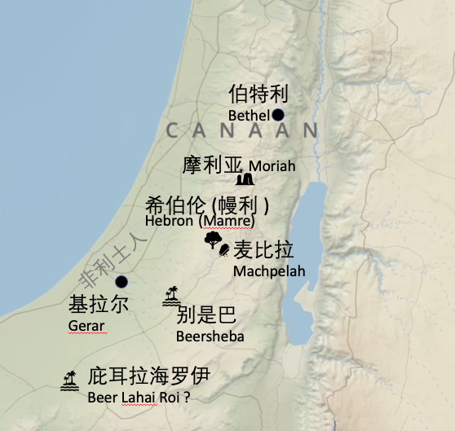
READ GENESIS 23:3-4
阅读创23:3-4
The city of Hebron where Sarah died was in Hittite territory, which extended south of the area surrounding Jerusalem. The Hittites were a Canaanite tribe that was heavily invested in idolatry. They were one of the groups that God commanded to be wiped off the earth as judgment for generations of idolatry when the people of Israel conquered the land of Canaan. The Hittites may have originally come from northern Mesopotamia and their language may have been known by Abraham from the years that he spent in Haran. Abraham approached the leaders of the Hittites in the city gate of Hebron in an effort to buy a burial site for his wife.
撒拉去世之地希伯仑位于赫人的区域，就是耶路撒冷南部周围的地区。赫人乃是迦南的一个部落，那里拜偶像盛行。以色列人征服迦南的时候，神命令他们从那地除灭的人群之一就是赫人，这是他们世代拜偶像所遭受的审判。赫人原本来自被美索不达米亚，亚伯拉罕曾经在哈兰多年，可能明白他们的语言。亚伯拉罕到赫人领袖那里去，就是到希伯仑城门那里，想要为他的妻子买一块墓地。

READ GENESIS 23:5-20
阅读创23:5-20
- Why did the Hittites make a generous offer to Abraham to give him any one of their best tombs as a burial place? (see verse 6 for a hint)
赫人非常慷慨，给亚伯拉罕最好的坟地来做墓地，他们为什么这么做？（参考第6节作为暗示）

- Why was it so important to Abraham that he purchase a burial site at full price rather than receive it as a gift from the Hittites?
亚伯拉罕用足价买了一块墓地，而不是让赫人白白送给自己，这一点为什么很重要？

Abraham paid what appears to be a very high price for this field and cave. 400 shekels of silver would be more than a year’s wages in today’s economy. Perhaps Ephron recognized that Abraham was a man of great wealth and could afford such a price, and the amount he quoted was an attempt to take advantage of Abraham at this time of grief when Abraham needed to act quickly. The Bible records that the prophet Jeremiah purchased a field of land for just 17 shekels of silver (Jeremiah 32:9). So the price of 400 shekels of silver seems very high.
为了这块田和其中的洞，亚伯拉罕出了很高的价钱。按照现在的价值来说，四百舍客勒银子相当于一年的薪酬。或许以弗仑看出亚伯拉罕是个富有的人，出得起这个价钱。并且他开的价是为了占亚伯拉罕的便宜，因为那时候亚伯拉罕处在悲痛当中，需要快速决定。圣经记录了先知耶利米仅仅用十七舍客勒银子就买了一块田（耶32:9）。所以四百舍客勒银子真的很多。
But Abraham never hesitated to pay the large price. It is an indication of how much wealth the Lord had given to Abraham.
然而，亚伯拉罕二话没说就出了高价。这表明了主着实赐给亚伯拉罕巨大的财富。

Today the location of the cave of Machpelah is marked by a large monument built by Herod the Great at the time of Christ. In addition to Sarah, Abraham (Genesis 25:9), Isaac (Genesis 35:27-29), Jacob (Genesis 50:13), Rebekah and Leah (Genesis 49:30-31) are all buried within this cave.
今天麦比拉洞的位置上有基督时期希律王竖立的纪念碑。除了撒拉，亚伯拉罕（创25:9）、以撒（创35:27-29）、雅各（创50:13），以及利百加和利亚（创49:30-31）都埋在这个洞里。

