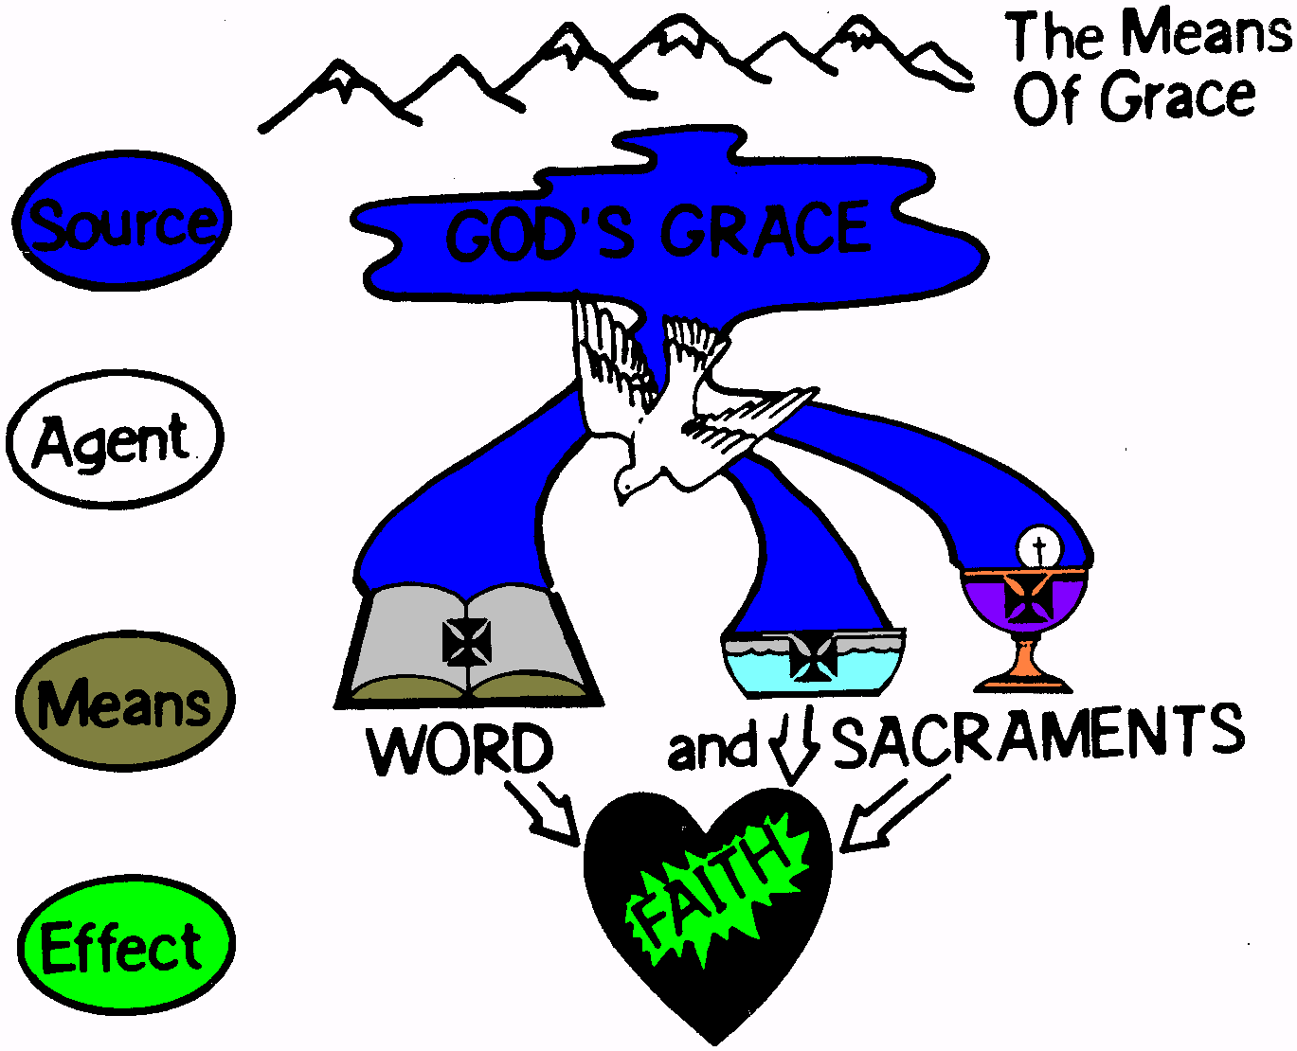
INTRODUCTION
来源
介绍
恩典的途径或管道
The means of grace is the gospel in word and sacraments.
神的恩典
恩典的通道是神话语和圣礼中的福音。
媒介物
The gospel is the good news of our forgiveness of sins proclaimed to us in the name of Jesus.
途径/方式
福音是宣告我们的罪因着耶稣的名被赦免的好消息。
话语
和 圣礼
效果
God graciously works faith in those who hear the gospel.
信心
神仁慈地在那些听到福音的人里面做工并制造信心。

God gives us forgiveness of our sins through the gospel whenever the gospel is preached. God also forgives our sins through the sacraments of Baptism and Holy Communion. The sacraments also are the gospel. Therefore both of the sacraments are the means of grace.
当福音被传讲时，神就透过福音把罪得赦免的恩典赐给我们。神也透过洗礼和圣餐礼的圣礼赦免我们的罪。圣礼也是福音，所以两个圣礼都是恩典的通道。

Think of how the farmer uses tools to break up the soil and plant seeds in the soil. Similarly, God the Holy Spirit uses the law to break the proud hearts of sinners. This is “contrition”. So also the Holy Spirit uses the His gospel promises to plant new life in those who believe the gospel.
想想农民怎样使用工具打碎土块，在土壤里播种种子。同样，圣灵也使用律法打碎罪人心里的骄傲，这就是“懊悔”。所以，圣灵也使用他的福音应许在那些相信福音的人里面播种新的生命。

Article 9: About Baptism
信条9：论洗礼
1] About Baptism our churches teach that it is necessary for salvation, 2] and that through Baptism God offers us his grace. Also, children ought to be baptized. Those brought to God through Baptism are received into God’s grace.
3] We condemn the Anabaptists, who reject the baptizing of children and say that children are saved without Baptism.
1]论到洗礼，我们教会教导：洗礼是救恩的必须，2] 而且神透过洗礼把他的恩典赐给我们；另外，儿童也必须要接受施洗。通过洗礼被带到神面前的人被接纳进入神的恩典中。
3]我们指责再洗礼派，他们反对给儿童施洗，说儿童不需要洗礼就可得救。

THE IMPORTANCE OF BAPTISM FOR THE CHURCH
洗礼对教会的重要性
Jesus commands the Church to baptize
耶稣命令教会执行洗礼
Matthew 28:18-20 Then Jesus came to them and said, "All authority in heaven and on earth has been given to me. Therefore go and make disciples of all nations, baptizing them in the name of the Father and of the Son and of the Holy Spirit, and teaching them to obey everything I have commanded you. And surely I am with you always, to the very end of the age."
太28：18-20耶 稣 进 前 来 ， 对 他 们 说 ： 天 上 地 下 所 有 的 权 柄 都 赐 给 我 了 。所 以 ， 你 们 要 去 ， 使 万 民 作 我 的 门 徒 ， 奉 父 、 子 、 圣 灵 的 名 给 他 们 施 洗 （ 或 作 ： 给 他 们 施 洗 ， 归 於 父 、 子 、 圣 灵 的 名 ） 。凡 我 所 吩 咐 你 们 的 ， 都 教 训 他 们 遵 守 ， 我 就 常 与 你 们 同 在 ， 直 到 世 界 的 末 了 。

God does not limit Baptism to any age group
神没有把洗礼限制在任何一个年龄段。

Note: The Greek words translated “all nations” are the very same words used by Matthew in 25:32; “all nations” will be gathered together on the Last Day for the judgment of all flesh.
注意：被翻译成“万民”的希腊词与马太在25：32节中使用的词完全是同一个词；“万民”都将在末后审判的日子聚集在耶稣的审判台前。

Here Jesus says that our mission is to make disciples of all nations. In the original Greek, baptizing and teaching are means by which people are “made disciples.”
耶稣在这里说，我们的使命是使万民作主的门徒。在希腊原文中，洗礼和教导是人们用来“造就门徒”的方式。

God’s grace comes through the Word preached and through the promise of forgiveness attached to Baptism.
神的恩典是通过传讲出来的话语与连结在洗礼中的赦罪应许赐给人的。

READ Mark 16:16.
读经 可16：16
- Baptism is “necessary” for salvation
1. 洗礼是得救的“必须”
  - Baptism is as necessary as the gospel is necessary.
a. 洗礼是必须的，正如福音是必须的。
READ Mark 16:15-16
读经：可16：15-16
15他 又 对 他 们 说 ： 你 们 往 普 天 下 去 ， 传 福 音 给 万 民 （ 万 民 ： 原 文 是 凡 受 造 的 ） 听 。 16信 而 受 洗 的 ， 必 然 得 救 ； 不 信 的 ， 必 被 定 罪 。
Jesus says that the good news (the gospel) is to be preached to all creation. People who “believe and are baptized will be saved”.
耶稣说，好消息（福音）要传给万民。“信而受洗的必然得救”。
READ John 3:5
读经： 约3：5 耶 稣 说 ： 「 我 实 实 在 在 的 告 诉 你 ， 人 若 不 是 从 水 和 圣 灵 生 的 ， 就 不 能 进 神 的 国 。
Jesus says that sinners must be born again by water and the Spirit (that is, “born again by the gospel in Baptism”) in order to enter into the Kingdom of God.
耶稣说，罪人若想要进神的国，就必须要被水和圣灵所生（就是“被洗礼中的福音重生”）。
READ 1 Peter 1:23
读经：彼前1：23你 们 蒙 了 重 生 ， 不 是 由 于 能 坏 的 种 子 ， 乃 是 由 于 不 能 坏 的 种 子 ， 是 藉 着 神 活 泼 常 存 的 道 。

The apostle Peter tells us that the Word of God is the seed that gives us new birth so that we are members of God’s Kingdom.
使徒彼得告诉我们，神的话就是给我们新生命的种子，使我们能成为神国的成员。
QUESTIONS: In what sense is Baptism “necessary for salvation”?
Why does Jesus tell Nicodemus (John 3) that Baptism is necessary to enter into the Kingdom of God?
问题：洗礼从哪种意义上讲是“救赎的必须”？
耶稣为什么对尼哥底母（约3）说，要进神的国就必须要接受洗礼？
READ Luke 7:29-30
读经：路7:29-30
众 百 姓 和 税 吏 既 受 过 约 翰 的 洗 ， 听 见 这 话 ， 就 以 神 为 义 ； 30但 法 利 赛 人 和 律 法 师 没 有 受 过 约 翰 的 洗 ， 竟 为 自 己 废 弃 了 神 的 旨 意 。 （29 ，30 两 节 或 作 ： 众 百 姓 和 税 吏 听 见 了 约 翰 的 话 ， 就 受 了 他 的 洗 ， 便 以 神 为 义 ； 但 法 利 赛 人 和 律 法 师 不 受 约 翰 的 洗 ， 竟 为 自 己 废 弃 了 神 的 旨 意 。 ）
Notice that the Pharisees refused to be baptized. This means the Pharisees refused the blessings of the gospel. Nicodemus was a Pharisee. Jesus warned Nicodemus that he could not enter God’s Kingdom if he continued to refuse the blessings of the gospel.
注意：法利赛人拒绝接受洗礼，就意味着法利赛人拒绝了福音的祝福。尼哥底母是一个法利赛人。耶稣警告尼哥底母，如果他继续拒绝福音的祝福，他就不能进入神的国。

CONCLUSION:
结论：
Baptism is not absolutely necessary for salvation. The blessings of the gospel may be received through the simple word of the gospel. Think of the criminal on the cross who repented and is in heaven through faith in Jesus (Luke 23:42-43). Was he baptized? Probably not.
洗礼不是救恩的绝对必须。福音的祝福可以透过福音的简单话语来领受。想想在十字架上悔改的罪犯，他因着相信耶稣就得以进入天国（路23：42-43）。他接受洗礼了吗？可能没有。
Baptism is not absolutely necessary for salvation. But Baptism is ordinarily necessary. Those who trust in the words of Jesus will want to be baptized to receive the blessings of the gospel which are available in Baptism and are given through Baptism.
洗礼不是得救恩的绝对必须，但洗礼按常理是必须的。那些相信耶稣话语的人会想要接受洗礼来领受福音的祝福，这祝福在洗礼中提供，透过洗礼赐给人。
Anyone who rejects Baptism is rejecting the gospel. Those who reject the gospel cannot be saved.
任何反对接受洗礼的人就是在反对福音。那些反对福音的人得不到救赎。

  - Baptism is God’s adoption proceedings; Baptism is “the sacrament of initiation”.
b. 洗礼是神接纳人的程序；洗礼是“入会式的圣礼”。
Titus 3:5 … he (God our Savior) saved us, not because of righteous things we had done, but because of his mercy. He saved us through the washing of rebirth and renewal by the Holy Spirit.
提多书3：5他 （神我们的救主）便 救 了 我 们 ； 并 不 是 因 我 们 自 己 所 行 的 义 ， 乃 是 照 他 的 怜 悯 ， 藉 着 重 生 的 洗 和 圣 灵 的 更 新 。

- Baptism is a means of grace.
2. 洗礼是恩典的通道

  - Children need the saving grace of God in Christ.
a. 孩童需要神在基督里的救恩

Our children are sinners from conception
我们的孩子从成胎起就是罪人。

Psalm 51:5 Surely I was sinful at birth, sinful from the time my mother conceived me.
诗篇51：5 我 是 在 罪 孽 里 生 的 ， 在 我 母 亲 怀 胎 的 时 候 就 有 了 罪 。

Our children are accountable for their sinfulness.
我们的孩子也要为他们的罪负责任。

Ezekiel 18:20 The soul who sins is the one who will die. The son will not share the guilt of the father, nor will the father share the guilt of the son. The righteousness of the righteous man will be credited to him, and the wickedness of the wicked will be charged against him.
结18：20惟 有 犯 罪 的 ， 他 必 死 亡 。 儿 子 必 不 担 当 父 亲 的 罪 孽 ， 父 亲 也 不 担 当 儿 子 的 罪 孽 。 义 人 的 善 果 必 归 自 己 ， 恶 人 的 恶 报 也 必 归 自 己 。

  - Anyone of any age who is brought to God through Baptism is received by grace in God’s Kingdom.
b. 任何年龄段的任何人，只要通过洗礼被带到神的面前，就靠着恩典被接纳进入神的国度。

Since the sacrament is the gospel and God works faith through his gospel, we trust that He can cause our children to believe through this sacrament. The miracle of faith in children through Baptism is no more incredible than the miracle of faith in adults. Conversion comes from God and the power of the gospel, not the ability of mankind to make a choice.
因为圣礼是福音，而且神透过他的福音做工生出信心。我们相信他能使我们的孩子通过这一圣礼来相信。通过圣礼在孩子心里产生信心的神迹绝不比在成年人心里生出信心的神迹更难以令人相信。悔改是从神和福音的能力来的，不是人类自己有能力做出的决定。

- Children ought to be baptized.
3. 孩童应该接受洗礼。

  - Jesus invites and welcomes the children.
a. 耶稣邀请并欢迎孩童。
Luke 18:15-17 People were also bringing babies to Jesus to have him touch them. When the disciples saw this, they rebuked them. But Jesus called the children to him and said, "Let the little children come to me, and do not hinder them, for the kingdom of God belongs to such as these. I tell you the truth, anyone who will not receive the kingdom of God like a little child will never enter it."
路18：15-17 有 人 抱 着 自 己 的 婴 孩 来 见 耶 稣 ， 要 他 摸 他 们 ； 门 徒 看 见 就 责 备 那 些 人 。耶 稣 却 叫 他 们 来 ， 说 ： 让 小 孩 子 到 我 这 里 来 ， 不 要 禁 止 他 们 ； 因 为 在 神 国 的 正 是 这 样 的 人 。我 实 在 告 诉 你 们 ， 凡 要 承 受 神 国 的 ， 若 不 像 小 孩 子 ， 断 不 能 进 去 。

We must keep in mind that Baptism is a work of God and not of man. Otherwise we stand to lose all the joy and comfort God wants us to get from our Baptism.
注意：我们必须记住洗礼是神的工作，不是人的工作。否则我们就会失去神要我们从洗
礼中得到的一切喜乐和安慰。

God can work faith in the heart of little babies as well as adults. The Greek word in these passages which are translated, “babies” or “infancy” are only used of unborn children or infants. So when church bodies in the world insist that babies are too young to have faith, they aren’t learning that from the Word of God, but rather from their own sinful reason.
神既能在成年人心里做工生出信心，也同样能在小婴儿心里生出信心。在这些经文中被译为“婴儿”或“婴孩”的希腊语都只是用来指未出生的孩子或婴儿。所以当世界上的教会坚持说婴儿太小不能有信心时，他们的说法不是从学习神的话语得出的结论，而是他们自己有罪理性的推论。

  - The ancient Church baptized babies.
b. 初期教会为婴儿施洗。
Acts 16:33 At that hour of the night the jailer took them and washed their wounds; then immediately he and all his family were baptized.
传16：33 当 夜 ， 就 在 那 时 候 ， 禁 卒 把 他 们 带 去 ， 洗 他 们 的 伤 ； 他 和 属 乎 他 的 人 立 时 都 受 了 洗 。

Jesus welcomed and blessed the babies who were brought to him.
耶稣欢迎并祝福带到他面前的婴孩。
For the same reason the first believers had their children baptized. Through baptism they were assured that God extended his grace also to their children.
因着同样的原因，第一批信徒给他们的孩童施行了洗礼。透过洗礼他们得到确据，神也将他的恩典赐给了他们的孩子

Justin Martyr (ca. A.D. 89-166) called Baptism “the circumcision of the New Testament”. Justin Martyr’s writings indicate that infants were baptized while the apostle John was still living.
殉道士游斯丁（约公元 89-166)称洗礼为“新约的割礼”。他在他的作品中指出，使徒约翰还在世时，就有为婴儿施行的洗礼。

Polycarp (died A.D. 168) testified that he had served Jesus for 86 years as he was being put to death for his faith. This statement by Polycarp indicates that he began to serve Jesus as an infant. That points to the year A.D. 82!
坡旅甲(卒于公元 168)因为信仰而被治死，在临死前他见证说他侍奉耶稣86年。坡旅甲的这些话指出，他从婴孩起就开始侍奉耶稣，那是在公元后82年。

The church father, Origen, born A.D. 185, tells us the practice of baptizing children was handed down to them from the apostles.
出生于公元185年的教会先辈奥利根告诉我们，给孩童施洗的做法是使徒传给他们的。

Irenaeus (A.D. 202), who was a disciple of Polycarp, who was a disciple of the Apostle John, wrote: "Christ came to save all men by himself; all, I say, who through him are reborn into God; infants, little children, boys, young men and old men."
爱任纽（公元202年），是坡旅甲的门徒。坡旅甲是使徒约翰的门徒。爱任纽写到：“基督亲自来拯救万民，我说的是所有人，是那些藉着他重生而进到神里面的人，包括婴儿，小孩，男孩，年轻人和老人。”

The great Augustine, born A.D. 353, said he never heard of anyone who accepted the Bible as God's Word who also rejected infant baptism.
出生于公元353年的大奥古斯丁说，他从来没有听说过任何一个把圣经看作是神话语的人会同时拒绝给婴儿施洗。

Numerous inscriptions on the graves in the catacombs, dating back to the very first centuries of Christianity, testify to the fact that the early Christians baptized their children. Here is one: “Aristus lived eight months. He was recently baptized."
可追溯到基督教最初几个世纪的无数地下墓穴的碑文证明了早期基督徒给孩童施洗的事实。其中一个碑文上有这样的话：亚里斯图活了八个月。他近期接受了洗礼。

- Therefore we condemn those who despise Baptism as a means of grace
4. 因此，我们谴责那些藐视洗礼是恩典通道的人。
  - The Anabaptists rejected clear biblical teaching about Baptism.
a. 再洗礼派反对圣经对洗礼的清楚教导。
This sect which rejected infant baptism during the days of the Reformation was known by the name of Anabaptists. Anabaptists were anti-trinitarians, who also believed that baptism wasn’t a necessary means of grace for sinful children born in this world.
在革新时期反对给婴儿施洗的派别称为再洗礼派。再洗礼派反对三位一体的教义，他们也相信，洗礼对生在这个世界上的有罪孩童来说，不是必须要有的恩典通道。

  - Those who reject Baptism do so because they exalt reason over the Scriptures.
b. 那些反对洗礼的人之所以如此反对，是因为他们高举理性过于圣经。
Today we have a church which calls itself the Baptist church, but the Baptists are not descended from the Anabaptists of the time period of the Reformation. There is no historical connection to this sect. There are, however, several groups of Baptists who have the same basic understanding that infant baptism is not a legitimate baptism and many of these Baptist churches insist that immersing a person under water is the only proper way for a baptism to be performed.
今天有一个自称为浸礼会的教会，但浸礼会信徒并不是革新时期再洗礼派的延续，它和这个异教教派没有历史上的联系。然而，浸礼会中有好几个类别，他们对给婴儿施洗的理解基本相同，都认为婴儿施洗不合理；这些浸礼会的很多教会坚持，把人浸到水中才是唯一正确的洗礼模式。

Is there any danger to withhold baptism from a baby, according to the Bible? The answer is yes! You are endangering the child by withholding the blessings of baptism from a child that is born into this world, “dead in trespasses and sins” (Ephesians 2:1). Also, the parents are also tempting God by despising this precious means of grace and withholding it from their child.
从圣经看，拒绝给婴儿施洗有没有任何危险？答案是“是的！”你不把洗礼的祝福赐给生在这个世界上的孩童就是在让他们遭遇危险，让他们“死在过犯与罪孽中”（弗2：1）。同样，那些因为厌弃这一宝贵恩典通道而不让孩子接受这一恩典的父母就是在试探神。

Remember Article 2 – Original Sin. There is a reason that the teaching about original sin occurs very early in the Augsburg Confession. If we do not understand and believe this truth about ourselves, we will be inclined to think a baby does not need Baptism.
记住信条2——原罪。论原罪的教导在奥格斯堡信纲的开头就出现是有原因的。如果我们不理解并相信有关我们自己的这个真理，我们就会倾向于婴儿不需要洗礼的想法。

Review of Article 9 – About Baptism
信条9内容回顾——论洗礼

Prepare your answers so that you can help us to review Article 9 (About Baptism) as we begin our next session.
准备好你的答案，帮助我们复习信条9论洗礼的内容。

- Agree or Disagree: Jesus restricts Baptism to some of the population (and leaves other people out) when he tells His Church to make disciples by baptizing and teaching (Matthew 28:19).
同意还是不同意：当耶稣告诉他的教会要去通过洗礼和教导使人成为门徒时，他只让一部分人接受洗礼，而把其余的人排除在外。

- Agree or Disagree: 1 Peter 3:18-22 tells us that Baptism is based on the gospel and is therefore a means of grace. The gospel is “the resurrection of Jesus Christ”; thus Baptism is able to and does save us.
同意还是不同意：彼前3:18-22 告诉我们，洗礼的根据是福音，因此洗礼是恩典的通道。（同意：福音是“耶稣基督的复活”；因此洗礼能够而且确实拯救我们。）

- How do the following verses indicate
3. 以下经文怎样表明
  - That Baptism is a means of grace?
a. 洗礼是恩典的通道?

  - That children may and should be baptized?
b. 孩童可以而且必须要接受洗礼？

Acts 2:38-39 Peter replied, “Repent and be baptized, every one of you, in the name of Jesus Christ for the forgiveness of your sins. And you will receive the gift of the Holy Spirit. The promise is for you and your children and for all who are far off—for all whom the Lord our God will call.
传2：38-39 彼 得 说 ：“你 们 各 人 要 悔 改 ， 奉 耶 稣 基 督 的 名 受 洗 ， 叫 你 们 的 罪 得 赦 ， 就 必 领 受 所 赐 的 圣 灵 ；因 为 这 应 许 是 给 你 们 和 你 们 的 儿 女 ， 并 一 切 在 远 方 的 人 ， 就 是 主 ─ 我 们 神 所 召 来 的 。”

- Analyze this statement: “Infant baptism is rejected, because only an adult can consciously perform an act of obedience,” as a Baptist confession of 1688 puts it; “in order to be baptized one must actually profess repentance towards God, faith in and obedience to our Lord Jesus Christ.” Since children cannot do this, they therefore are not to be admitted to baptism.
4.分析这一说法：- “婴儿受洗不被接受，因为只有成人才能有意识地做出顺服的举动，”1688年浸礼会的信仰告白中这样写道，“一个人必须真正地向神公开承认自己的悔改、心里有信心而且顺服我们的主耶稣基督，才能接受洗礼” 。 因为婴儿做不到这一点，所以他们不能接受洗礼。

5. We should remember that Baptism is
5. 我们应该记住：洗礼是__________。
____ using water to symbolize the washing away of sins.
____用水来象征把罪洗掉。
____ special "holy water" blessed in a church ceremony.
____在教会仪式中被祝福的特殊“圣水”。
____ water plus the Word of God, used according to God’s command.
____按照神的命令使用的水，加上神的话。（正确）

6. If someone one rejects Baptism,
6. 如果一个人拒绝洗礼，____________。
____ this is a result of unbelief and results in condemnation.
这是他不信的结果，而且将要受审判。
____ it doesn’t make that much difference as long as you believe in Jesus.
只要你相信耶稣，受不受洗不会有多大区别。
____ we don’t know what will happen to that person.
我们不知道那个人将会怎样。

Reading Assignment for Next Session
下节课阅读作业
Augsburg Confession
奥格斯堡信纲
Article 10: About the Lord’s Supper
信条10：论圣餐

1] About the Lord’s Supper our churches teach that the body and blood of Christ are truly present under the forms of the bread and wine and are given to those who eat the Lord’s Supper. 2] We reject those that teach anything else.
1]论到主的圣餐，我们教会的教导是，基督的身体和血以饼和酒的形式真实同在，而且赐给那些吃圣餐的人。2] 我们反对任何其它教导。

Optional Reading Assignment for Next Session
下节课可选性阅读作业
The Defense of the Augsburg Confession Article IX
About the Holy Supper
奥格斯堡宣言信条9—论圣餐的辩护文

The English translation can be found at
英文翻译可在以下网址找到：
http://bookofconcord.org/defense_8_holysupper.php

The Unaltered Augsburg Confession by Glen L. Thompson © 2005 Northwestern Publishing House. Used with permission.
Baptized into God’s Family by A. Andrew Das, NPH, 1991, pages 98-101. Das and other historians have concluded that Polycarp was 86 years old when he died and therefore was baptized as an infant. 由A-安德鲁·达斯所著受洗归入神的家NPH, 1991, 第 98-101页.达斯与其他历史学家得出这样的结论：坡旅甲殉道时86岁，所以他是在婴儿时期就接受了洗礼。
The Unaltered Augsburg Confession by Glen L. Thompson © 2005 Northwestern Publishing House. Used with permission.

